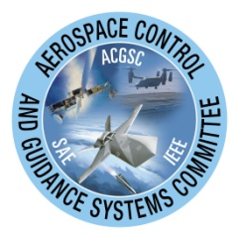
Aircraft System Identification Theory and Practice

A Short Course by Dr. Gene Morelli

Date: March 6, 2012 (held in conjunction with Meeting #109 of the Aerospace Control and Guidance Systems Committee)

Course fees of $485 includes a copy of the AIAA textbook of same name, CD with SIDPAC software and course notes, breakfast, and lunch

Course Description

This course teaches the theory and practice of building mathematical models for aircraft dynamics based on measured data. The methods are useful for flight simulation development, aircraft stability and control flight testing, comparisons with computational fluid dynamics and wind tunnel results, flight envelope expansion, control system design and refinement, flying qualities assessment, accident investigation, and more. The course includes relevant theory and background, but focuses mainly on practical approaches and solutions. All aspects of aircraft system identification are included: experiment design, instrumentation, data handling, model formulation, model parameter estimation, and model validation. The course includes instruction in the use of a MATLAB® software toolbox called SIDPAC (System IDentification Programs for AirCraft), which is composed of a wide variety of tools used at NASA Langley and elsewhere to solve aircraft system identification problems. The course also includes practical hands-on experience, allowing students to become familiar with the use of the SIDPAC software on real flight data and to interpret the results.

Who Should Attend

The course will be useful to flight test engineers, simulation engineers, control system designers, aircraft designers, applied aerodynamicists, flying qualities engineers, engineering managers, and anyone who needs to identify high fidelity mathematical models based on measured data from an experiment, or understand how it can be done.

Key Topics

Background and introduction
Mathematical models for aircraft
Modeling in the time and frequency domains
Experiment design, instrumentation, and data handling
Real-time dynamic modeling
System IDentification Programs for AirCraft (SIDPAC) MATLAB® software
Hands-on practical experience

